R programming mini project report
1. Introduction
Agriculture plays a vital role in the global economy, and crop yield analysis is essential for improving productivity and decision-making. This project focuses on analyzing crop yield data using statistical techniques in R programming.
The objective is to:
- Compare yield differences among different crop types
- Analyze the effect of geographic regions on yield
- Apply One-Way and Two-Way ANOVA
- Perform assumption checks and post-hoc analysis
2. Tools and Technologies Used
- Programming Language: R
- Libraries:
  - tidyverse (data manipulation)
  - car (statistical tests)
  - ggplot2 (visualization)
- Dataset: FAOSTAT Crop Yield Dataset

3. Data Description
The dataset contains agricultural data including:
- Item → Crop type
- Area → Region/Country
- Element → Type of measurement (Yield, etc.)
- Value → Crop yield (kg/ha)
Only records where Element = "Yield" were used for analysis.

4. Data Preprocessing
The dataset was cleaned using the following steps:
- Removed unnecessary rows
- Filtered only "Yield" values
- Removed missing values (NA)
- Converted categorical variables into factors:
  - Item
  - Area
This ensured data suitability for statistical analysis.

5. Exploratory Data Analysis (EDA)
Basic exploration was performed using:
- head() → Preview dataset
- str() → Structure of dataset
- summary() → Statistical summary
- Frequency tables for categorical variables
Key Observations:
- Multiple crop types were present
- Yield values varied significantly across crops
- Some variation was observed across regions

6. One-Way ANOVA
Objective:
To check whether mean crop yield differs across crop types (Item).
Model Used:
$$Value∼Item$$
R Code:
model <- aov(Value ~ Item, data = data)
summary(model)
Result Interpretation:
- If p-value < 0.05, there is a significant difference in crop yields among crop types.
- This indicates that crop type has a strong influence on yield variation.

7. Assumption Testing
7.1 Homogeneity of Variance (Levene’s Test)
leveneTest(Value ~ Item, data = data)
- Checks if variance is equal across groups.
7.2 Normality Test (Shapiro-Wilk Test)
shapiro.test(residuals(model))
- Checks if residuals follow a normal distribution.

8. Post-Hoc Analysis (Tukey Test)
TukeyHSD(model)
Purpose:
To identify which specific crop pairs differ significantly in yield.

9. Data Visualization
Boxplot of Crop Yield
A boxplot was created using ggplot2:
- Shows distribution of yield for each crop
- Helps identify:
  - Median differences
  - Outliers
  - Variability
Insight:

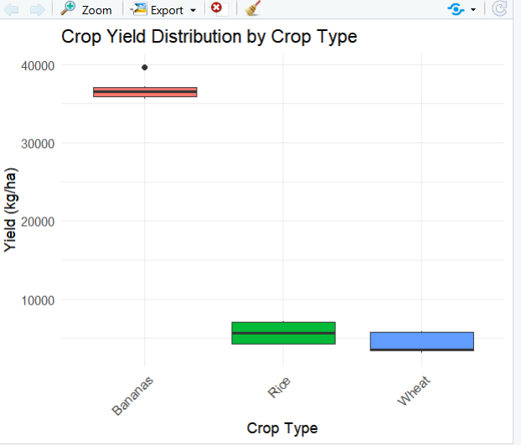
Some crops show higher median yield and wider variation compared to others.

10. Two-Way ANOVA
Objective:
To analyze the effect of:
- Crop type (Item)
- Region (Area)
- Interaction between both
Model:
$$Value∼Item+Area+Item:Area$$
R Code:
model2 <- aov(Value ~ Item + Area + Item:Area, data = data)
summary(model2)
Interpretation:
- Item effect → Differences between crop types
- Area effect → Differences between regions
- Interaction effect → Whether crop performance changes across regions

11. Results Summary
- Crop type significantly affects yield.
- Region also influences yield in many cases.
- Interaction effect may indicate that certain crops perform better in specific regions.
- Data visualization supports statistical findings.

12. Conclusion
This study demonstrates that both crop type and geographical region significantly influence crop yield. ANOVA analysis in R effectively identifies differences and relationships in agricultural data.
The findings can help:
- Farmers choose better crops
- Policymakers improve agricultural planning
- Researchers understand yield variation patterns

13. Future Scope
- Use regression models for prediction
- Include climate and soil variables
- Build interactive dashboards using Plotly or Shiny
- Apply machine learning for yield forecasting

14. Appendix (R Code Summary)
Includes:
- Data cleaning
- One-way ANOVA
- Two-way ANOVA
- Assumption testing
- Visualization

